# **OpenH264 build and update for wme**

Table of Contents

OpenH264 build and update for wme 1

1. Build and update 2

1.1 Basic flowchart 2

1.2 Script for build and update 3

1.3 Check previous build/update history 3

1.4 Build and update 4

1.4.1 basic flow chart 4

1.4.2 script 5

1.4.3 Example: 6

2. Download from ftp server 8

2.1 Basic info 8

2.1 Basic flowchart 9

2.2 Script 10

2.2.1 check version 10

2.2.1 download 11

3. To do 12

# Build and update

## Basic flowchart

Unify option name for skip build and download from ftp server is:

openh264-skip-build

Example:

for mac build, go to wme/build/mac and run:

sh build.sh openh264-skip-build

script will skip openh264 build and download from ftp server.



## Script for build and update

* build/ios/buildAndupdate_openh264.sh
* build/mac/buildAndupdate_openh264.sh
* build/windows/build_openh264.py
* mediaengine/shark/bld/client/android/build.py
* build/linux/build.sh

## Check previous build/update history



Example: for mac, in script file: build/mac/buildAndupdate_openh264.sh

Check openh264 commit ID



Check openh264 lib exist or not, with the same commit ID

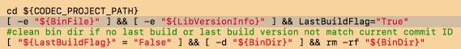

## Build and update

### 1.4.1 basic flow chart



### 1.4.2 script

Example: for mac, in script file: build/mac/buildAndupdate_openh264.sh

For mac,

* if last build is also for mac, not for ios/android etc.
* last build is the same arch : x86_64 or i386 etc
* last build is the same build cfg: Release or Debug

increment build only, for mac case, only using command:

* make
* no make clean



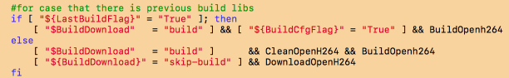

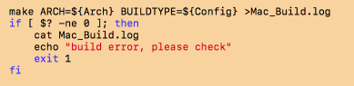

### 1.4.3 Example:

**git submodule command to get openh264 commit ID**

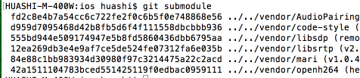

**Build for ios with dev/release**

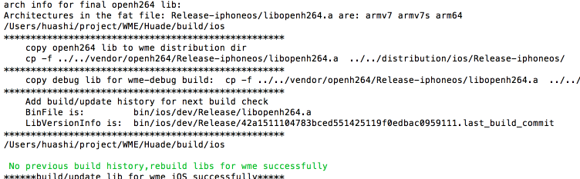

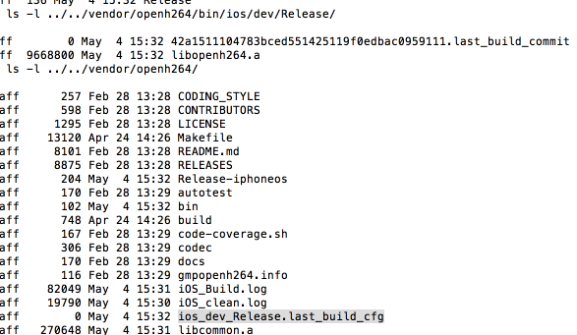

**Build for mac with x86_64/Release**

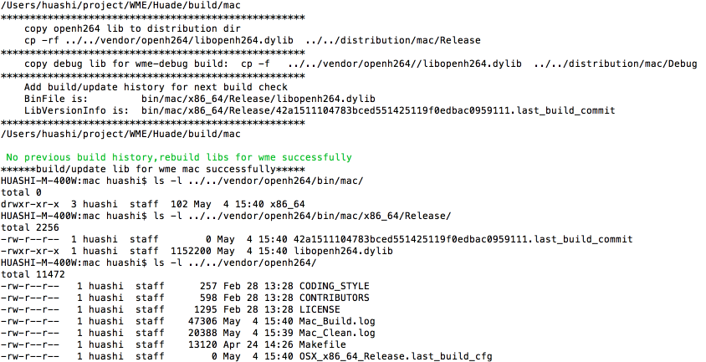

# Download from ftp server

## **2.1 Basic info**

* FTP server: <ftp://10.224.203.70/JenkinsRelease/>

Account: OpenH264/wme@cisco

* FTP server wiki: <https://wiki.cisco.com/display/WX2/OpenH264+ftp+server>
* Tools for upload and download from ftp server

<https://sqbu-github.cisco.com/huashi/OpenH264-Release2FTPServer>

* In wme, also using curl tools to download from ftp server

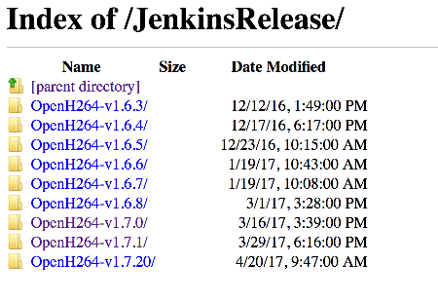

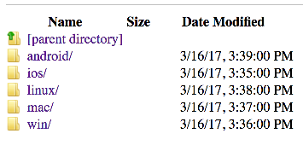

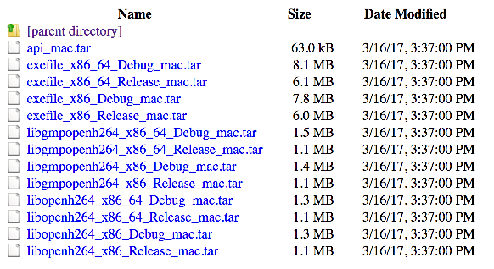

## Basic flowchart



## Script

### 2.2.1 check version

build/ios/buildAndupdate_openh264.sh

build/mac/buildAndupdate_openh264.sh

build/windows/build_openh264.py

**parse openh264 version info from:**

vendor/openh264/codec/api/svc/codec_ver.h

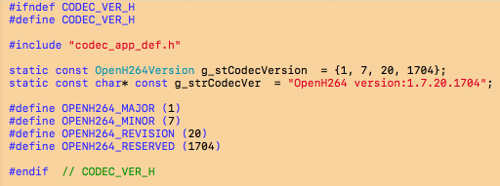

**Script for check version:**

**Example for android**

mediaengine/shark/bld/client/android/build.py

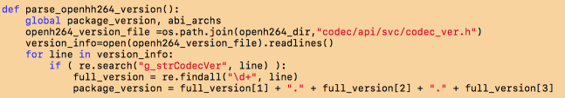

**ios/mac, using tools from to complete all version check and download process**

<https://sqbu-github.cisco.com/huashi/OpenH264-Release2FTPServer>

### download

**ios/mac, using tools from to complete all version check and download process**

<https://sqbu-github.cisco.com/huashi/OpenH264-Release2FTPServer>

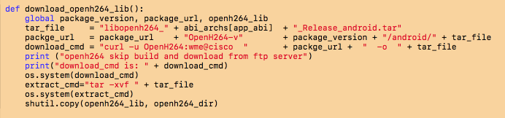

**ios/mac, using tools from to complete all version check and download process**

<https://sqbu-github.cisco.com/huashi/OpenH264-Release2FTPServer>

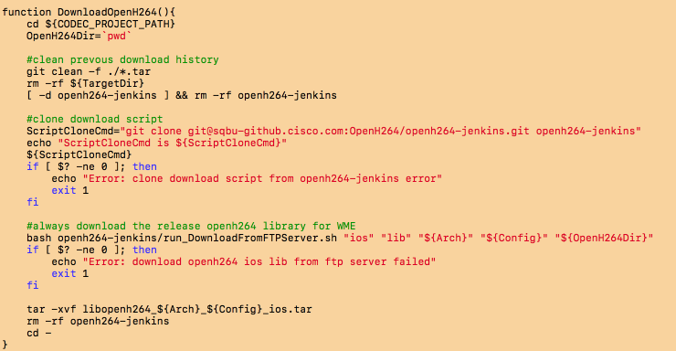

# To do

* unify build and update script in openh264 internal repos
* windows build support VS2015, VS2017 etc.
* Incremental compile for all OS bout script level and Make file level